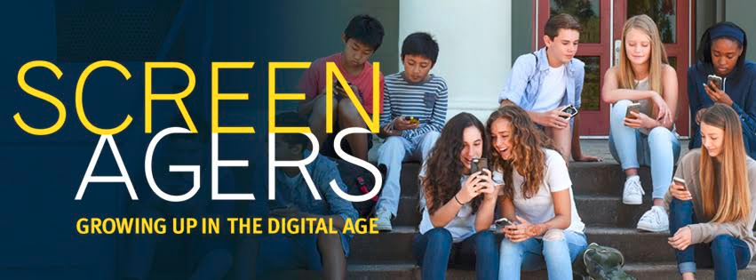
Screenagers: Growing up in the Digital Age
Thursday, February 16, 2017 at 6:00pm
TJ Auditorium
Free and open to the public
Run time ​68 minutes
Directed by​ Delaney Ruston, M.D.
Reserve your seats

Screenagers is about the impact of the digital age on teens/kids and how to help them minimize harmful effects and find balance. After seeing the film, people comment that they feel more confident and better equipped to establish balance in their families around screen time.

We’ve all been there--arguing with our families about putting phones away during dinner or socializing on Snapchat when homework isn’t finished. Or maybe you’ve had discussions about the appropriateness of social media posts or photo sharing. What rules are fair? Online bullying, sexting, or simply the belief that "if it's on the internet it must be true"... these are just a few of the trials our teens face in the digital world that didn’t exist much more than a decade ago.
Screenagers probes into the effects of too much screen time and how families can approach some of these digital challenges. This hour-long documentary covers the messy struggles we face over social media, video games, academics and internet addiction. Through surprising insights from authors, psychologists and brain scientists, solutions emerge on how we can be empowered to best navigate the digital world. Screenagers is appropriate for adults and kids 10 and older. However, many parents with kids younger than 10 have reported they were happy they did. However, it's not recommended for age 7 or younger.
Watch the trailer and read the movie review. Invite your friends, family and neighbors. Free and open to the public.

Popcorn and refreshments will be available for purchase.

Reserve your seats!

P.S. The film is not being made available through theaters, Netflix or YouTube. The producers' intent is to make it available exclusively through community forums such as schools in order to spark conversation. Hope to see you there!

